Contents

Introduction 1

Pre-requisites 1

Creating a VS.Net Project 1

Deploying to Windows Azure 5

# Introduction

The purpose of this demo is to show the user how to build a cloud service with Visual Studio tooling. There are a lot of taking points around the edges of this which can be made mainly through references back to the slides.

# Pre-requisites

Visual Studio 2012 – any edition

Windows Azure SDK

# Creating a VS.Net Project

Select File-> New Project -> Windows Azure Cloud Service

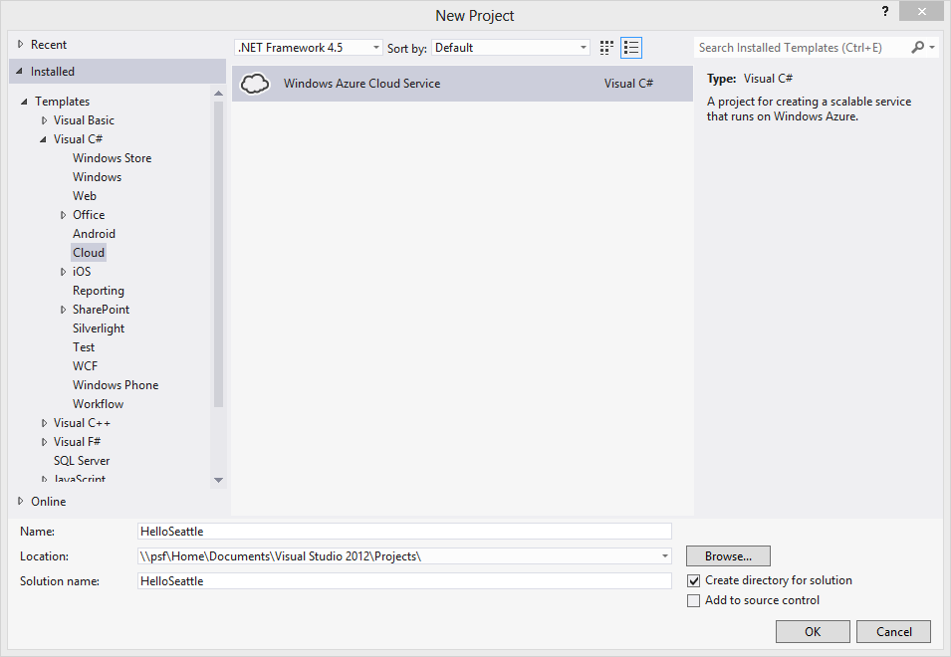

Enter the name and location of the project.

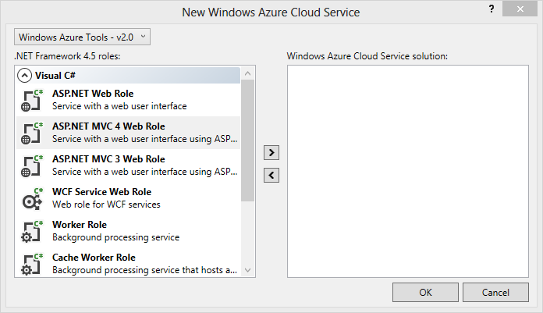

Select an ASP.NET MVC 4 Web role project and update the name per the dialogue below.

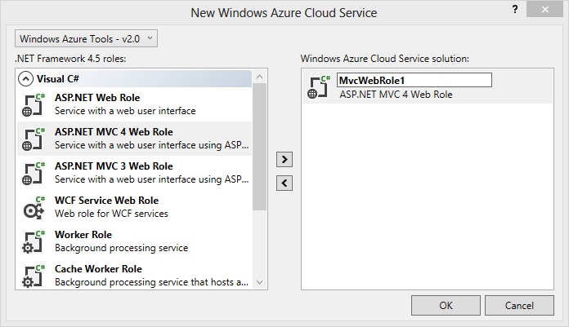

Create an empty ASP.NET MVC project per the image below.

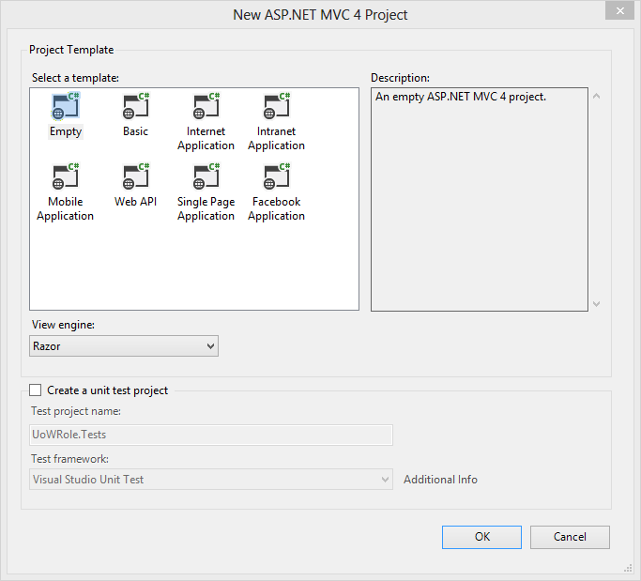

If the project was created with the name MsrWebRole then look for that project name of the projects that are now in the solution.

Right click on the Views folder in the project and choose Add -> New Folder. Name the folder **Home**

Right click on the new folder and choose Add->View. Choose the name Index for the new view.

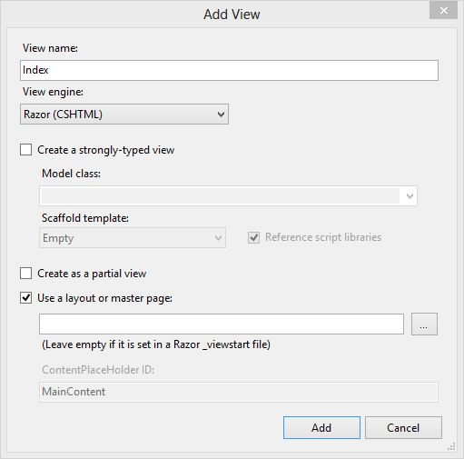

Replace the text of the new file with some new text like so:

<h1>A touch of English teaching in the United States</h1>

Right click on the Controllers folder and choose Add->Controller. Make sure that the controller name is **HomeController**.

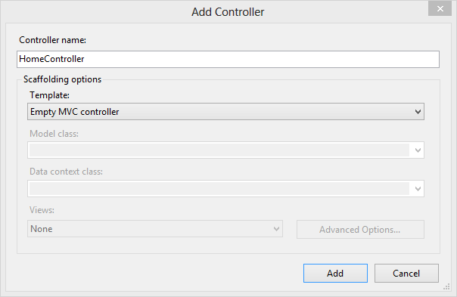

# Deploying to Windows Azure

Double click on the Role file like so:

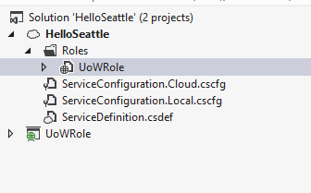

Uncheck enable diagnostics on the results pane.

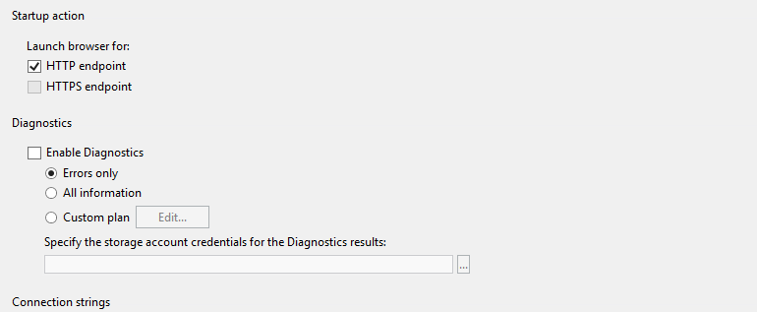

Right click on the cloud project and select Publish …

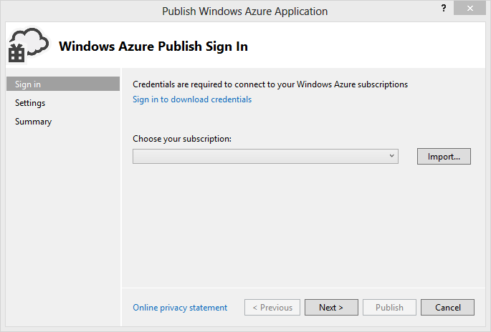

Click sign in to download credentials and enter the live id associated with the Windows Azure subscription.

You should have been navigated by browser to the following page.

<https://manage.windowsazure.com/publishsettings/index?client=vs&schemaversion=2.0>

Click import on the new publishsettings file.

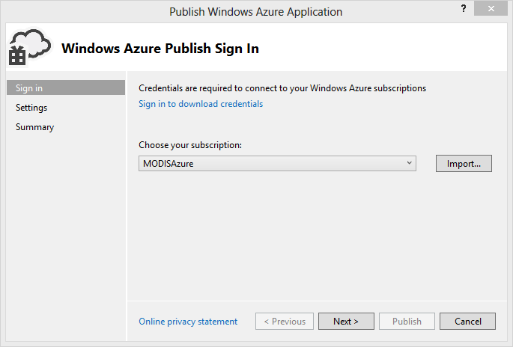

Follow the next step.

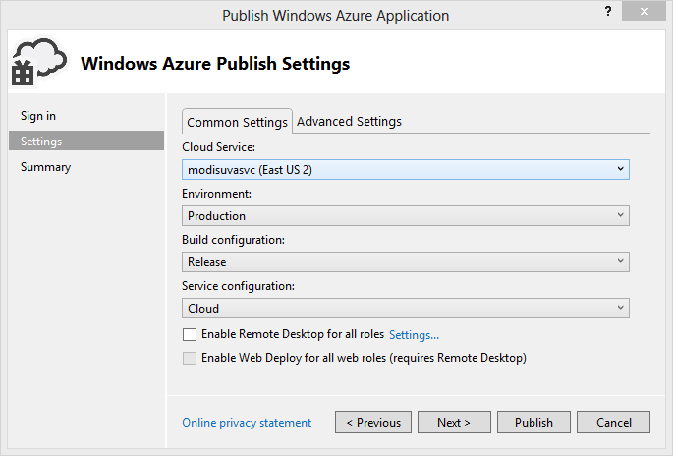

And choose a **Create New** cloud service from the dropdown list.

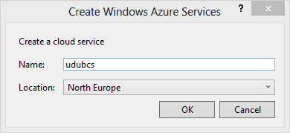

Switch to the advanced tab.

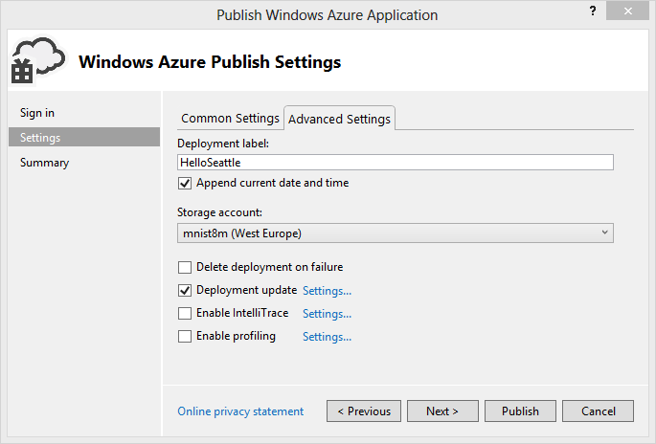

We now need to create a new storage account. At this stage a storage account is created and a vsdeploy container should be created and the package automatically uploaded by visual studio.

Select Storage Account -> Create new – ensure that the account is in the same region as the cloud service.

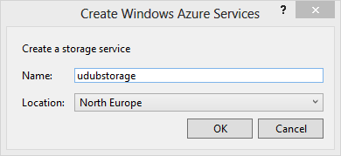

Finally click on the **publish** button on the dialogue.

Visual Studio will show an activity log which will describe the details of the deployment operation.

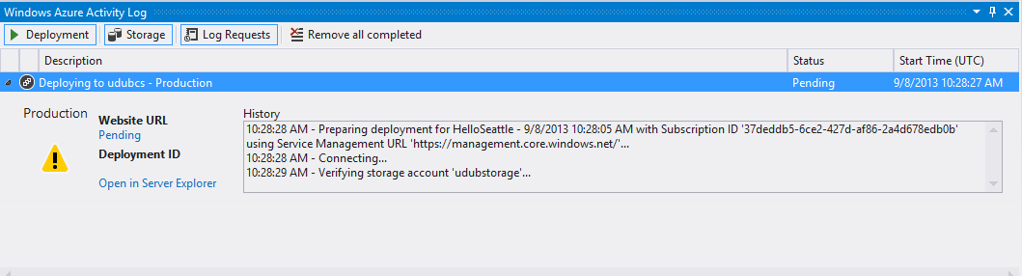

When the deployment is complete navigate to the cloud service.

You should now be able to navigate to the new website. Show and describe the website roles in the management portal and show the homepage of the site.